//Modified Text editor Demo (Not Much)

//Thinking about Advanced Text Processing (May take some weeks)

Programming by demonstration:

Similar to SUGILITE ~~(make a chrome extension)~~

it is used by developers to add voice commands and preset actions. Without modifying the current website, developers can add this script and generate code after enable a developer-mode flag. (Works on single page application/no redirect)

Steps:

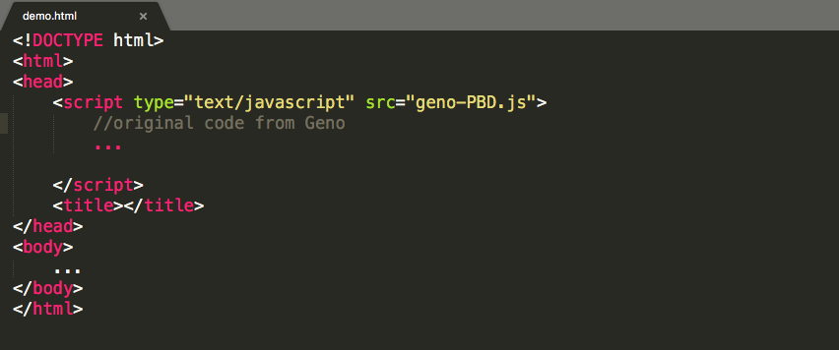

Input Command from Speech: I’d like to buy 2 orders of Frappuccino.

Some indicators to start.

Perform the Demo (How? Iframe? Possible Event (Hover, Click, Input, Select, another tab(#mailbox/trash)))

Some indicators to end.

Then developer select ‘2’(singular/plural) and ‘Frappuccino’ as parameters. (Process of extracting possible parameters automatable? Recognize number/actions/nouns?)

And Pick which identifiers to use for generalization

[Content (Substring or Some kinds of function) | Attribution | Structure (Probably wrapped by div)]

Code generation.

After:

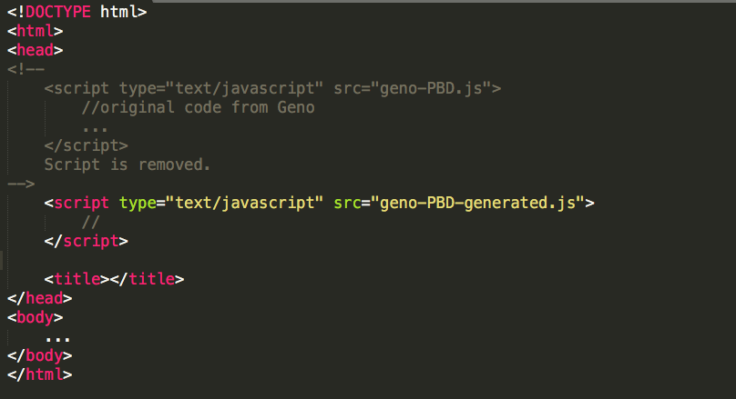

图片包含 文字, 白板



自动生成的说明

Some examples:

